Woods for Wood White
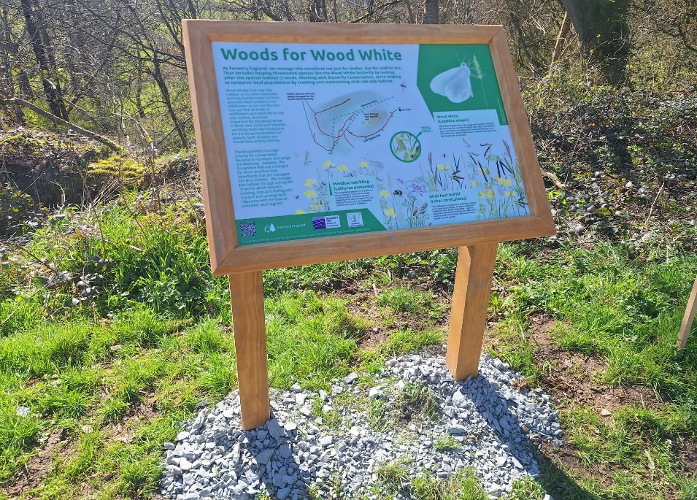
Project Summary
Figure 1. The new interpretation board in situ.

Project goals
The Woods for Wood White project sought to maintain and enhance the ride-side habitat and scallop refugia to support locally and nationally significant populations of the Wood White butterfly (Leptidea sinapis). The project focused on the surrounding woodlands of Bury Ditches Iron-Age hill fort in the Shropshire Hills.

Key achievements
The following shows how the project has delivered against the expected outcomes:

Target | Achieved
88 hours of volunteering time | 16 hours of volunteering time, with 4 volunteers over 1 day. Reduced from expected due to staff illness and poor weather.
Re-establishment of 2,570 square metres of high-quality ride side habitat | Over 5,900 square metres of habitat were cleared using a roboflail, establishing extra patches of ride side habitat across the site.
Outreach posts on social media platforms and internal blogs | 3 internal blog posts, 7 Facebook posts and a permanent page on the Forestry England website will be created to showcase the project.
Installation of new interpretation panel | With help of local artist, Sarah Jameson, we successfully created and installed the new interpretation panel in the Bury Ditches car park.

“Great work from the project staff. Lovely to see the story being told of our forestry work and its importance to the local community and Shropshire Hills National Landscape.”
Quote from Kevin Stannard, West District’s Forest Management Director on one blog post.

Additionally, the project has achieved the following outcomes:
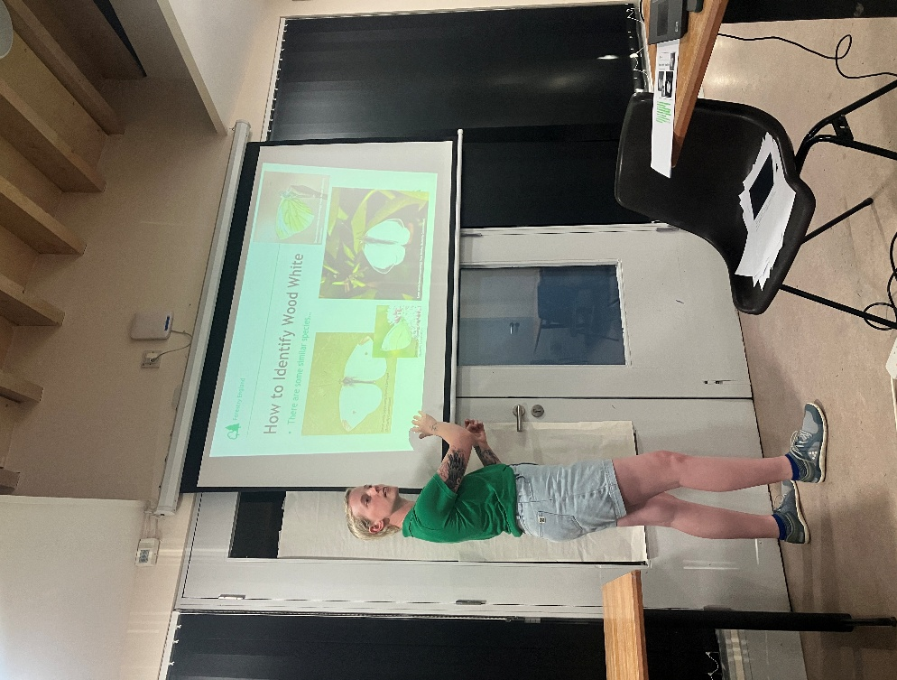
Figure 2. Kaitlyn delivering the talk at the Shropshire Hills Discovery Centre.
- Public engagement and awareness
We delivered two public talks on the project: one hosted by Forestry England at the Shropshire Hills Discovery Centre in May, attended by approx. 15 people, and a second as part of Going Wild in Bishop Castle’s winter talk series in early October, attended by around 35 people. We also attended the Shropshire Hills Summer 2025 Forum, and plan to attend the 2026 event too, showcasing the project’s achievements.

- Partnership working
Colleagues from Natural Resources Wales attended a visit to Bury Ditches to learn about our management strategies for Wood Whites, which have recently been found on their sites along the Welsh border. We hope to continue working with NRW and we plan to attend a volunteer day with NRW colleagues to support Wood White habitat creation on their key sites.
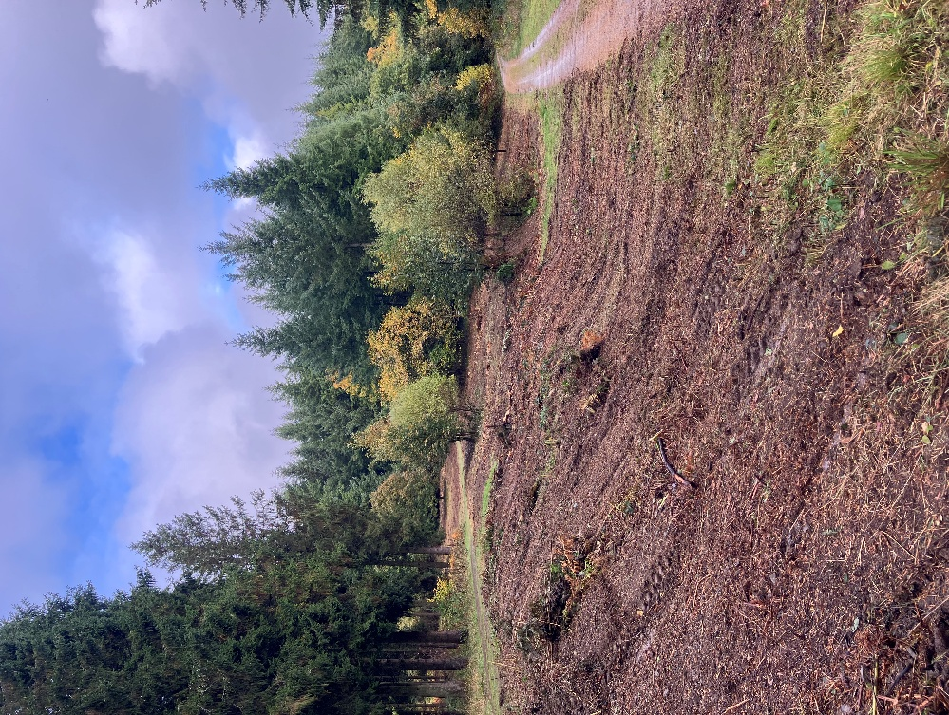
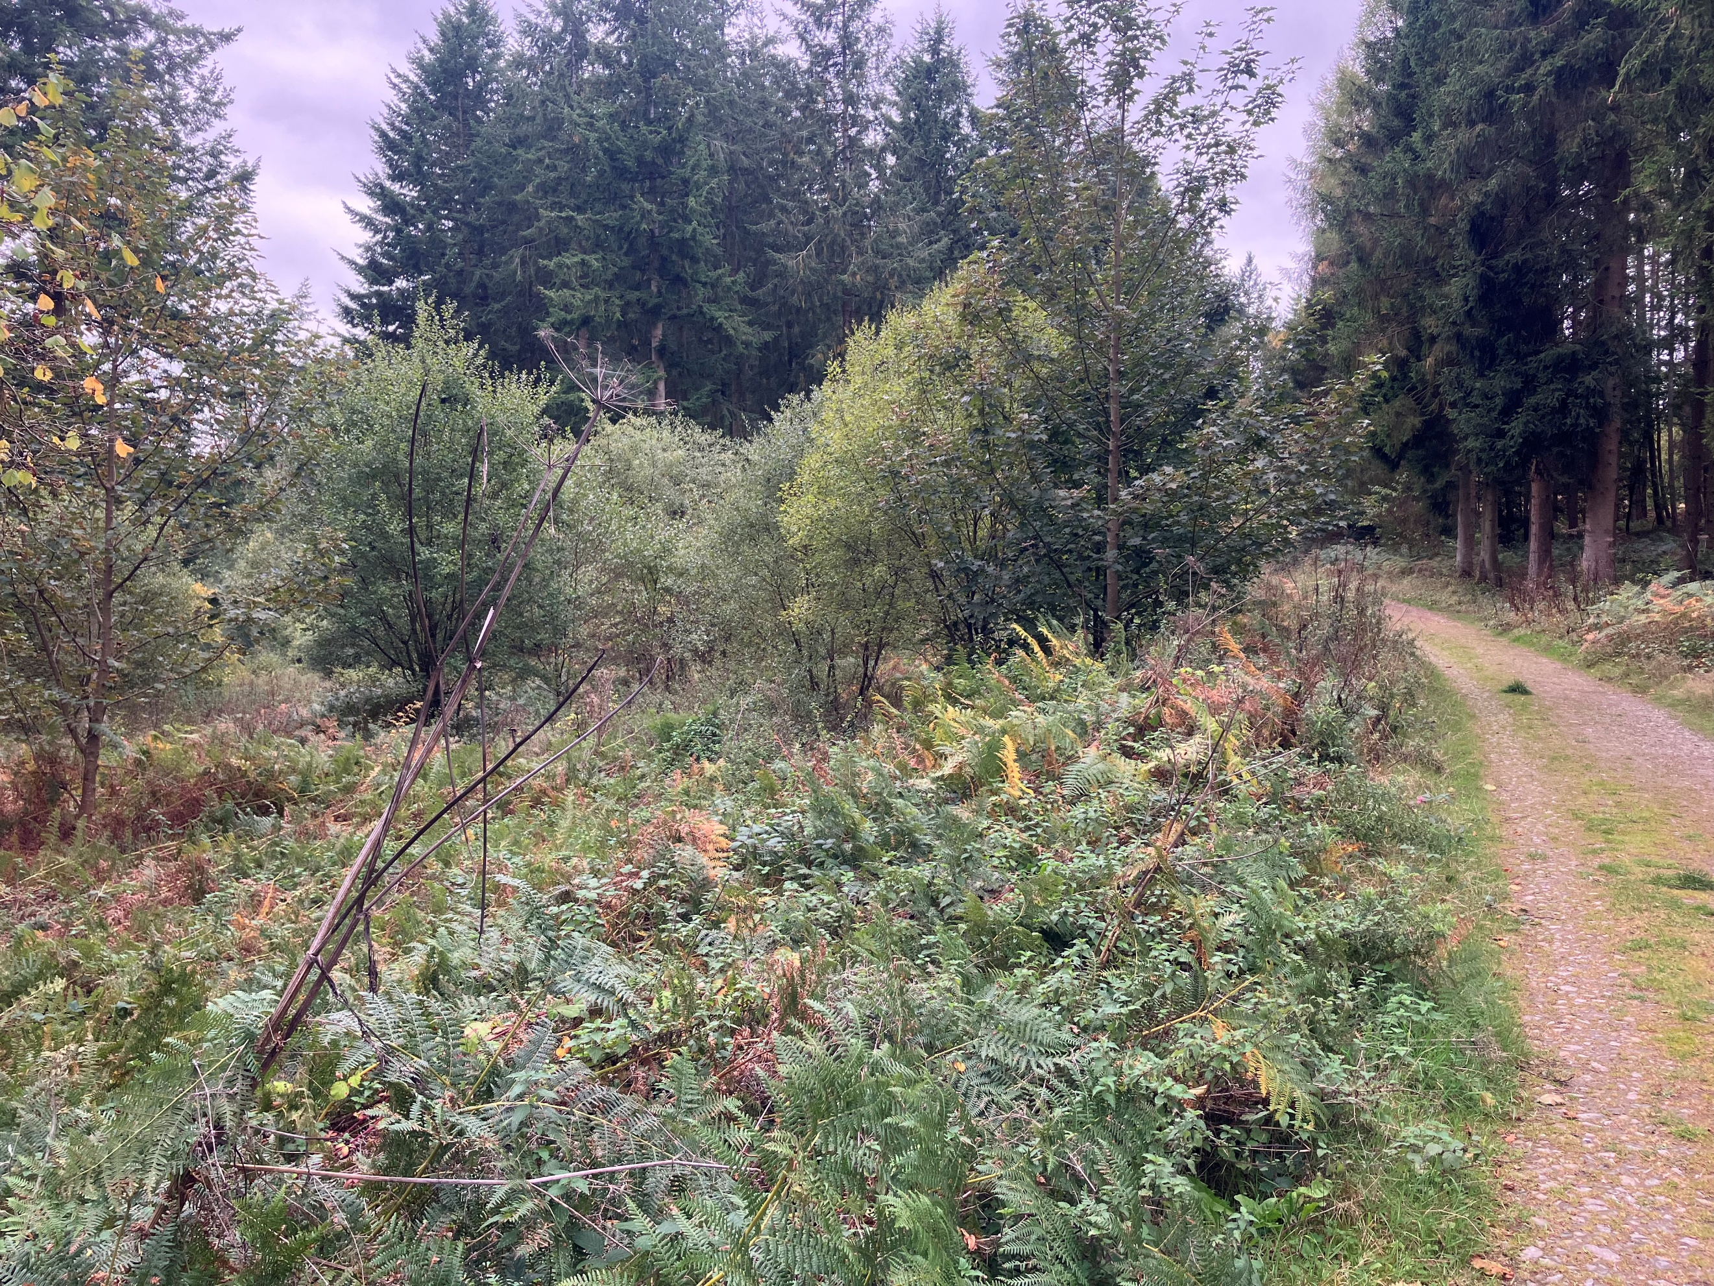
Figure 3. Before and after photos of clearance with the roboflail.

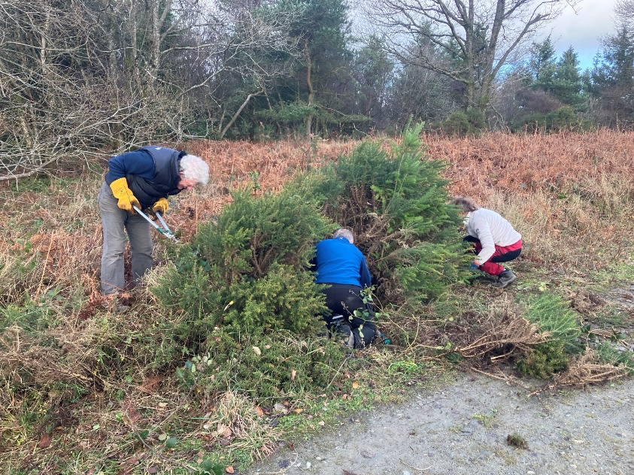
Figure 4. Volunteers cutting back gorse and broom.

Lessons learned and next steps
We’re very proud of the project’s achievements and have learned some key lessons that will allow us to improve on future projects:

- Alongside the volunteer sessions and habitat conservation work, harvesting works were occurring at Bury Ditches. We worked closely with the harvesting team to make sure the project didn’t interfere with harvesting and vice versa. Next time, we can use the harvesting as an engagement opportunity to show visitors the positive impact disturbance can have in woodlands for wildlife.
- We realised how valuable partnership working was, even to smaller scale projects. Building relationships with other wildlife groups like Going Wild in Bishops Castle allowed us to expand the reach of the project’s aims.
- Staff illness and poor weather meant we missed out on delivering more volunteer sessions. For future projects, we’ll be sure to schedule more sessions throughout the year, not just near the end of the project to maximise volunteer engagement.

The Woods for Wood White project provided us with a great foundation for future habitat or species projects in other local woodlands. We hope to use this project as a framework to apply for further internal or external grants to help conserve other protected species and create nature networks across the region.

We’d like to thank the Shropshire Hills National Landscapes team for their continued support on this project. Further photos can be obtained from Kaitlyn Elverson: Kaitlyn.elverson@forestryengland.uk

